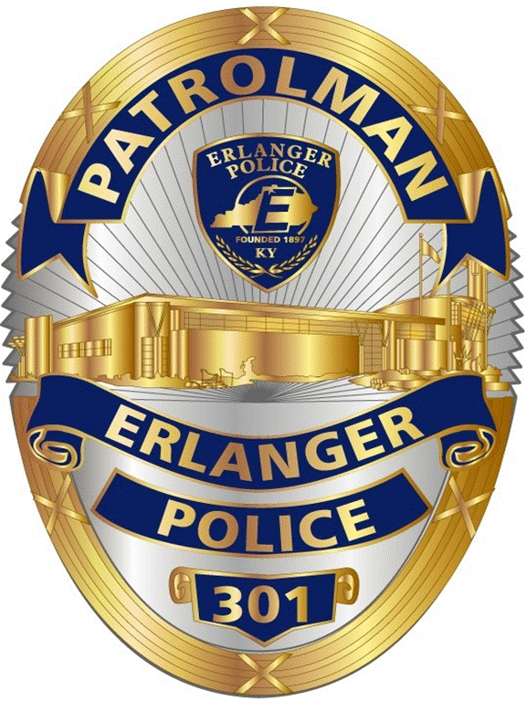

November 2021
ERLANGER POLICE MONTHLY REPORT

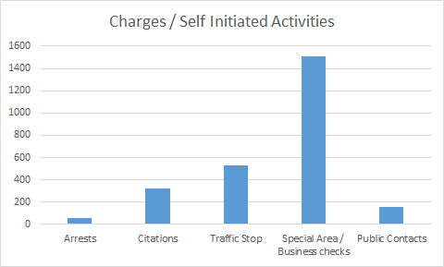 | 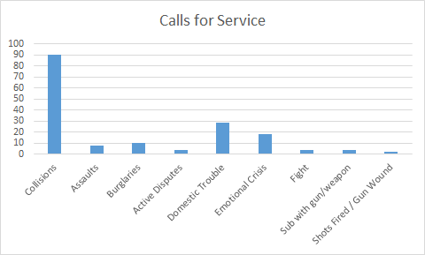

Programs: Community events this month included:
- Erlanger Police is an active participant in the Military to Law Enforcement Program (M-2-LE)
- Served meals at the City Senior Luncheon Event
- Erlanger / Elsmere FOP Lodge annual can food drive
- Thanksgiving meal delivery with the FOP Lodge
- Officer Hartke and K9 Keno were featured in the Vested
Interest Calendars
- Pizza Parties provided to Miles Elementary “Reading Challenge” Winners (partnered with Police Social Worker and CRO)

Training:
- Department Low light range qualifications
- PSW provided “Non-Fatal Strangulation” training to the Fire Department

Investigations/Case Highlights:
- Fatal Fire Investigation on Bullock Pen
- Shooting from Greenfield (no injuries)

